- Create a image from running container.
- Copy image from local machine to docker server and load the image.
- Create Docker image using alpine and customize with tomcat.
- Create single stage and multi stage docker file using this source code:
https://github.com/betawins/multi-stage-example.git
- Install docker compose and execute sample application.
- Implement solution to scan images when pushed to docker registry.
- Implement solution to scan images when pushed to AWS ECR.
- Create a Jenkins pipeline to create a docker image and push the image to Docker hub.

1. Create an Image from a Running Container

Objective
Create a Docker image from an already running and customized container using docker commit.

Outcome
You will understand how to convert the current state of a running container into a reusable Docker image.

Implementation Steps
Step 1 — Pull an image
docker pull nginx
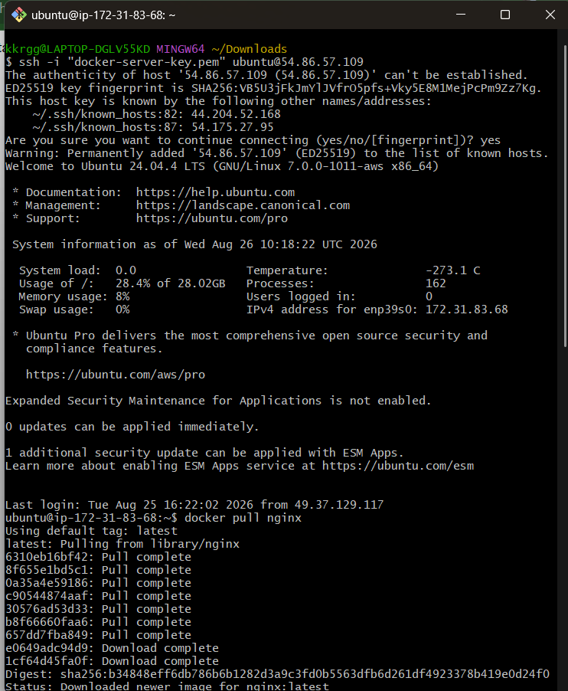
Step 2 — Run the container
docker run -d --name mynginx -p 8080:80 nginx
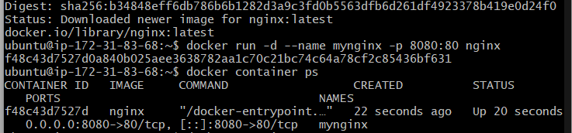
Step 3 — Enter the container
docker exec -it mynginx /bin/bash
Make a customization:
echo "Hello from customized nginx container" > /usr/share/nginx/html/index.html
Exit:
exit
Step 4 — Create an image from the running container
docker commit mynginx mynginx-custom:v1
Step 5 — Verify the image
docker images
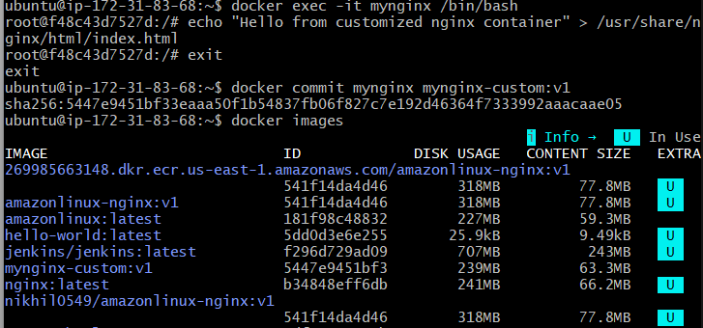
Step 6 — Run a new container from the image
docker run -d --name testnginx -p 8081:80 mynginx-custom:v1
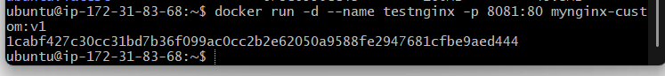

Validation
Open:
http://<server-ip>:8081
You should see:
Hello from customized nginx container
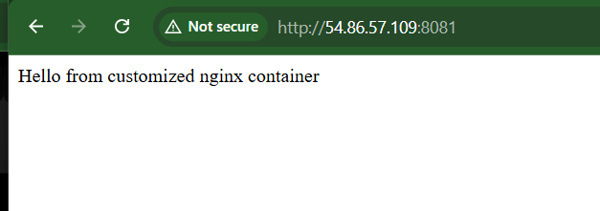

Important Interview Point
docker commit captures the current filesystem state of a container and creates a new image.
However, in real projects, Dockerfiles are preferred because they provide a reproducible and version-controlled image-building process.

2. Copy Image from Local Machine to Docker Server and Load the Image

Objective
Transfer a Docker image from one Docker host to another without rebuilding the image or pulling it from a registry.

Outcome
You will understand:
docker save
↓
image.tar
↓
scp
↓
Docker Server
↓
docker load

Implementation Steps

On Local Machine
Check images:
docker images
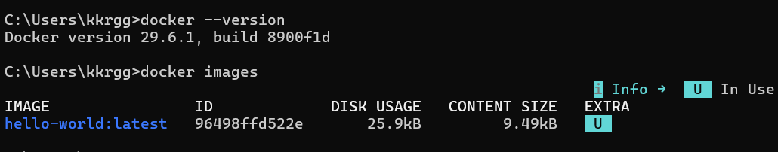
For example:
mynginx-custom v1
Save the image:
docker save -o mynginx-custom.tar mynginx-custom:v1
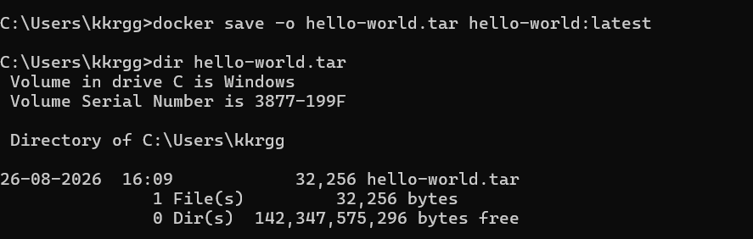
Verify:
ls -lh mynginx-custom.tar

Copy to Docker Server
Using SCP:
scp mynginx-custom.tar ubuntu@<docker-server-ip>:/tmp/
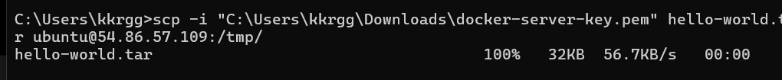

On Docker Server
Load the image:
docker load -i /tmp/mynginx-custom.tar
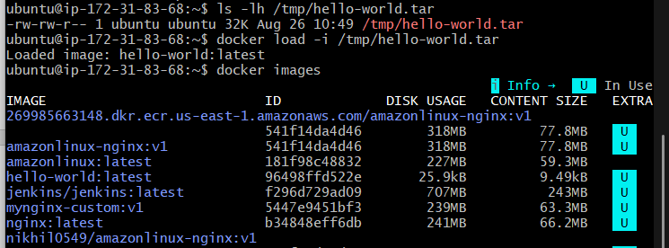
Verify:
docker images
You should see:
mynginx-custom v1
Run it:

docker run --rm mynginx-custom:v1

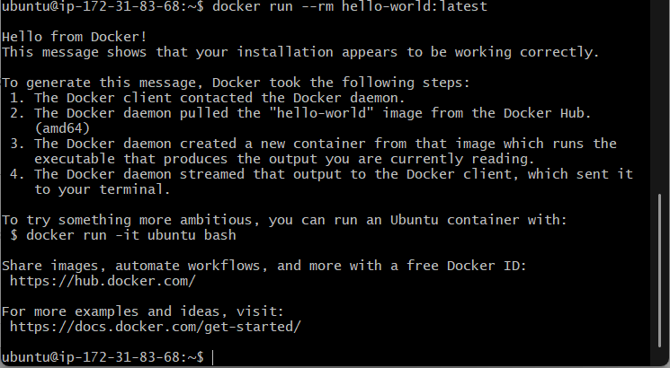

Important Difference
Command | Purpose
docker save | Saves an image to a tar archive
docker load | Loads an image from a tar archive
docker export | Exports a container filesystem
docker import | Creates an image from an exported filesystem
For image transfer, use:
docker save → docker load

3. Create Docker Image Using Alpine and Customize with Tomcat

Objective
Create a lightweight custom Docker image using Alpine Linux and install/configure Tomcat inside it.

Outcome
You will understand how to build a Docker image from a minimal base image and install application dependencies manually.

Implementation Steps
Create a directory:
mkdir alpine-tomcat
cd alpine-tomcat
Create:
Dockerfile
Example:
FROM alpine:3.20

RUN apk update && \
apk add --no-cache openjdk17-jre wget tar

ENV TOMCAT_VERSION=10.1.59
ENV CATALINA_HOME=/opt/tomcat
ENV PATH=$CATALINA_HOME/bin:$PATH

RUN mkdir -p /opt && \
wget https://dlcdn.apache.org/tomcat/tomcat-10/v${TOMCAT_VERSION}/bin/apache-tomcat-${TOMCAT_VERSION}.tar.gz && \
tar -xzf apache-tomcat-${TOMCAT_VERSION}.tar.gz -C /opt && \
mv /opt/apache-tomcat-${TOMCAT_VERSION} ${CATALINA_HOME} && \
rm apache-tomcat-${TOMCAT_VERSION}.tar.gz

EXPOSE 8080

CMD ["catalina.sh", "run"]
Build:
docker build -t alpine-tomcat:v1 .
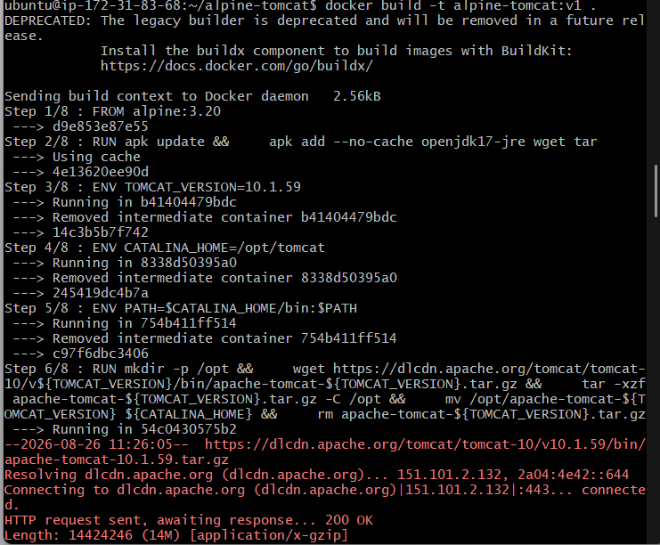

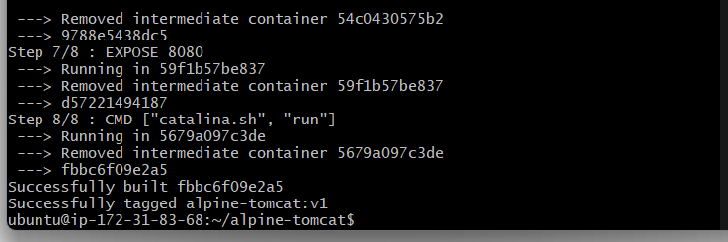
Verify:
docker images
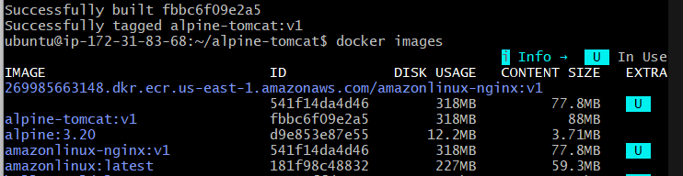
Run:
docker run -d \
--name alpine-tomcat \
-p 8080:8080 \
alpine-tomcat:v1
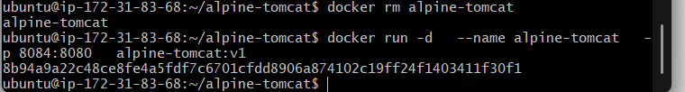
Check:
docker ps
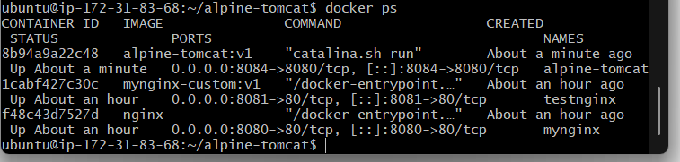
Test:
curl http://localhost:8080
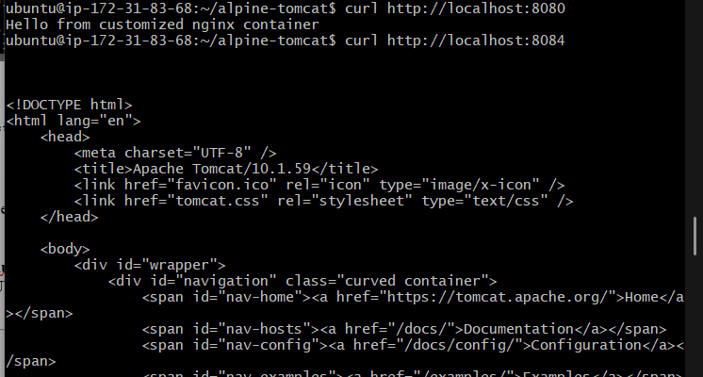

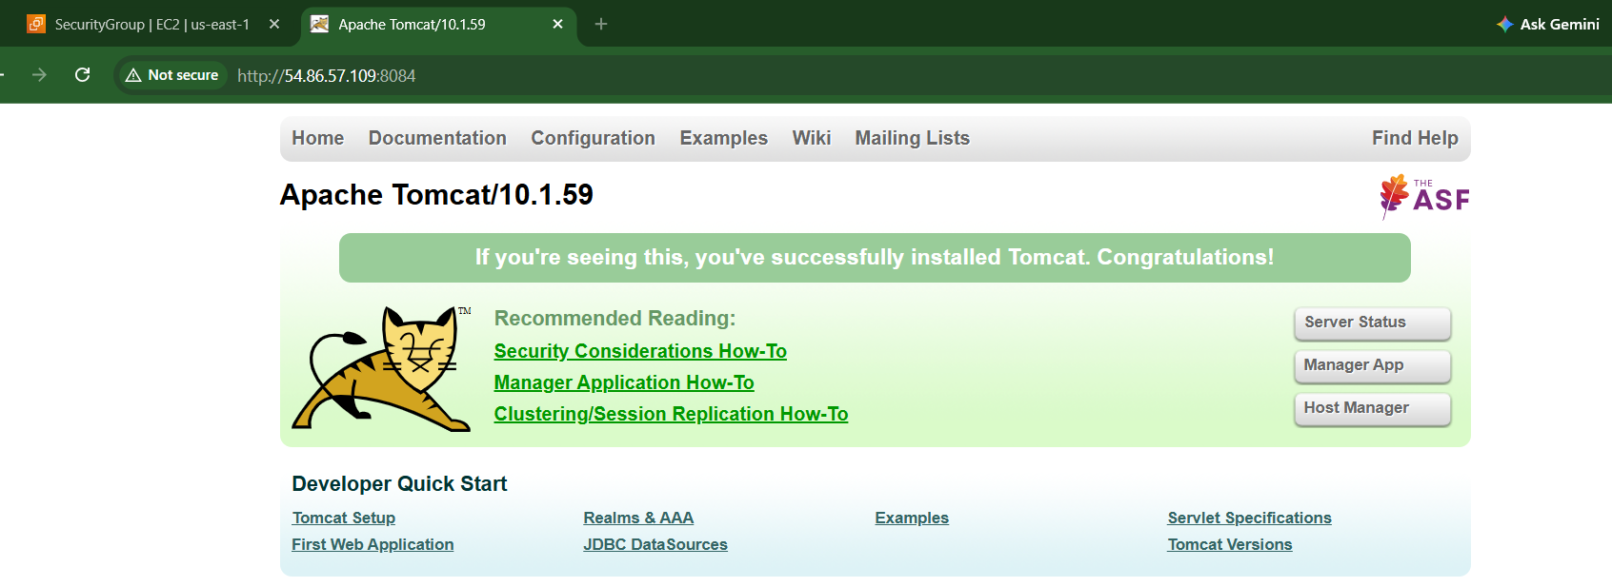

Important Interview Point
Alpine is popular because it is a small Linux distribution, which can help reduce image size.

4. Single-Stage and Multi-Stage Dockerfile
Source repository:
multi-stage-example GitHub repository

Objective
Create both a single-stage and multi-stage Docker image from the application source code and compare their image size and build process.

Outcome
You will understand why multi-stage Docker builds are commonly used in production.

Step 1 — Clone Repository
git clone https://github.com/betawins/multi-stage-example.git
cd multi-stage-example
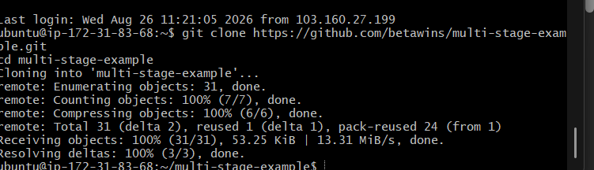
Check files:
ls -la
Inspect the project:
cat README.md
Also identify the application's build tool and source structure before writing the Dockerfile.
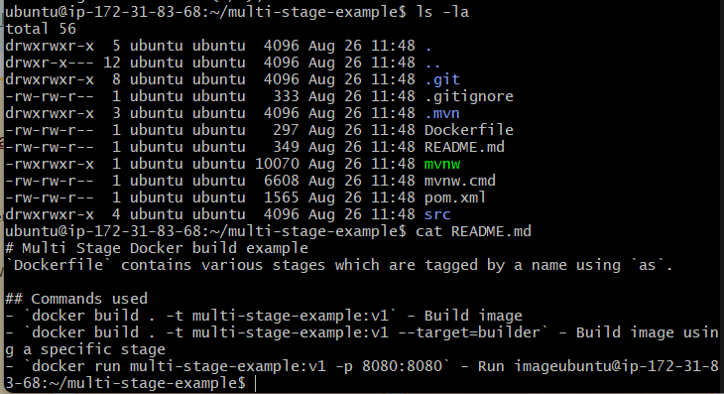

Now create the Single-Stage Dockerfile
For your task, create a separate file:
nano Dockerfile.single
Put:
FROM maven:3.8.8-eclipse-temurin-8

WORKDIR /app/source

COPY . .

RUN mvn clean package

EXPOSE 8080

ENTRYPOINT ["sh", "-c", "java -Djava.security.egd=file:/dev/./urandom -jar /app/source/target/*.jar"]

Build the Single-Stage Image
docker build -t multi-stage-single:v1 -f Dockerfile.single .

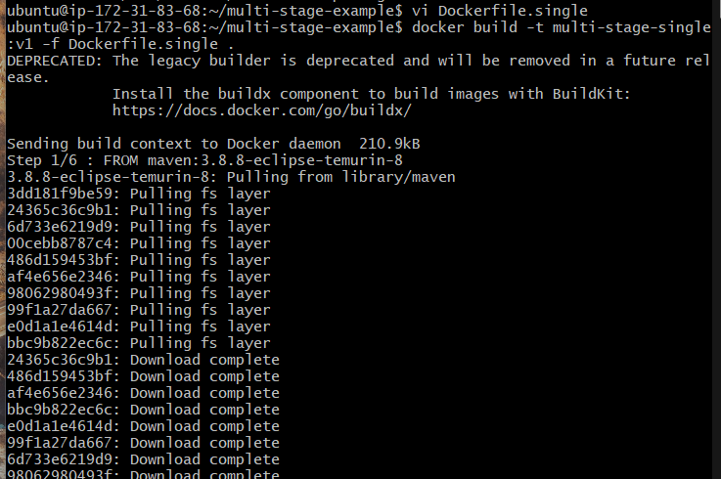

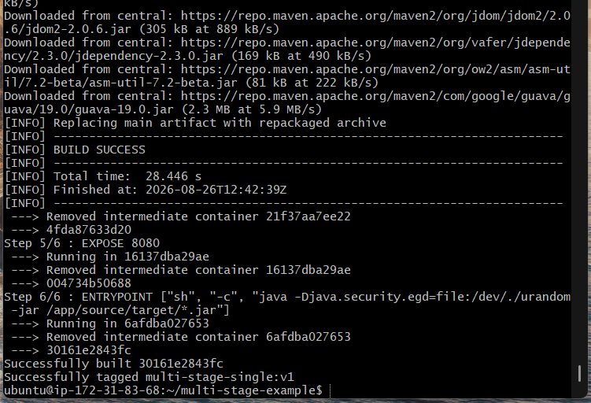
Check the image:
docker images
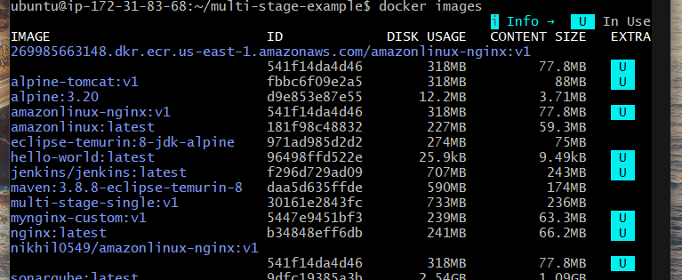

Multi-Stage Dockerfile
The concept is:
Stage 1
Build Environment
↓
Application Artifact
↓
Stage 2
Small Runtime Image
Example:
FROM maven:3.8.8-eclipse-temurin-8 AS builder

RUN mkdir -p /app/source

COPY . /app/source

WORKDIR /app/source

RUN mvn clean package

FROM eclipse-temurin:8-jre-alpine

COPY --from=builder /app/source/target/*.jar /app/app.jar

EXPOSE 8080

ENTRYPOINT ["java","-Djava.security.egd=file:/dev/./urandom","-jar","/app/app.jar"]
Build:
docker build -t multi-example-multi:v1 -f Dockerfile.multi .
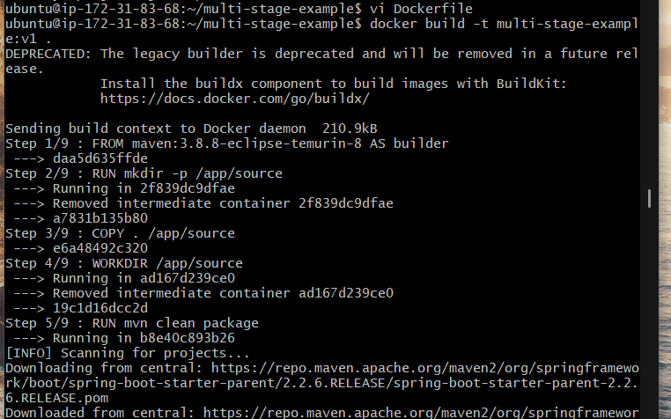

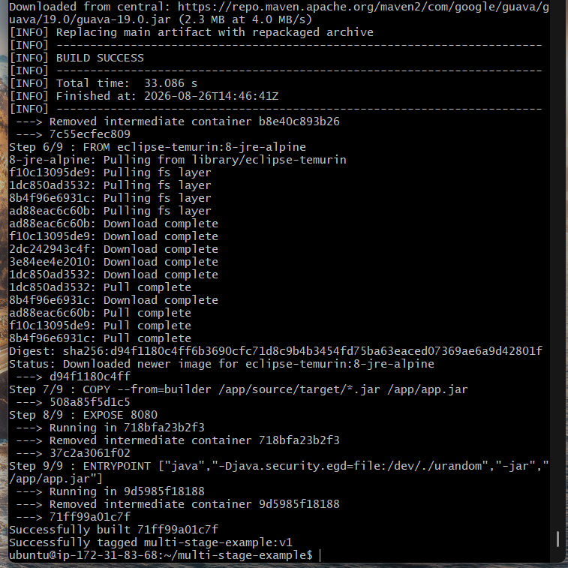
Check:
docker images
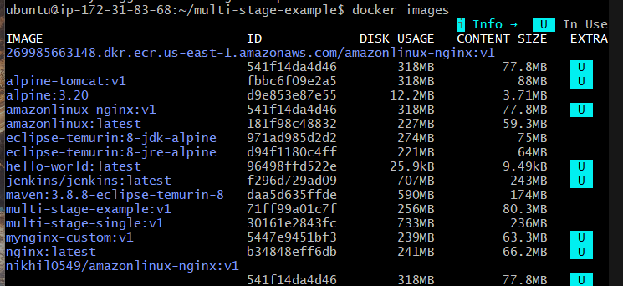

Compare
docker images | grep multi-stage
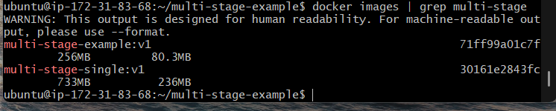
You should compare:
Single-stage image size
VS
Multi-stage image size

Why Multi-Stage?
The Maven image contains:
Maven
JDK
Source code
Build dependencies
Application
The final multi-stage image contains only what is required to run the application:
JRE
Application
Runtime dependencies
Therefore, multi-stage builds can provide:
- Smaller images
- Faster image transfers
- Smaller attack surface
- Better production images

5. Install Docker Compose and Execute Sample Application

Objective
Install Docker Compose and run a multi-container application using a compose.yaml/docker-compose.yml file.

Outcome
You will understand how Docker Compose manages multiple related containers as one application.

Step 1 — Check Docker
docker –version
Modern Docker installations commonly include Compose as:
docker compose version
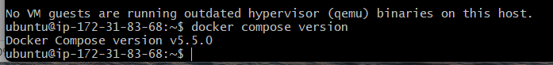

Step 2 — Create Project
mkdir compose-demo
cd compose-demo
Create:
vi compose.yaml
Example:
services:

web:
image: nginx:latest
ports:
- "8080:80"

redis:
image: redis:latest
Start:
docker compose up -d
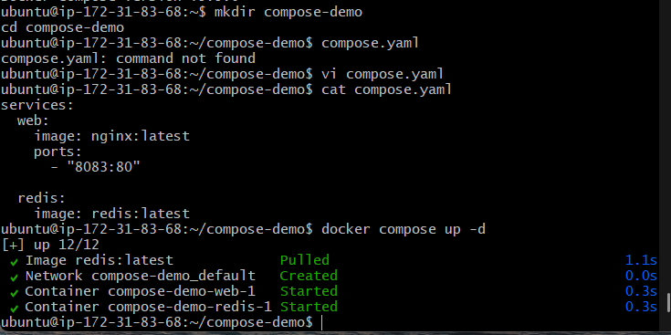
Check:
docker compose ps
You should have:
web
redis
Then test Nginx:
curl http://localhost:8083
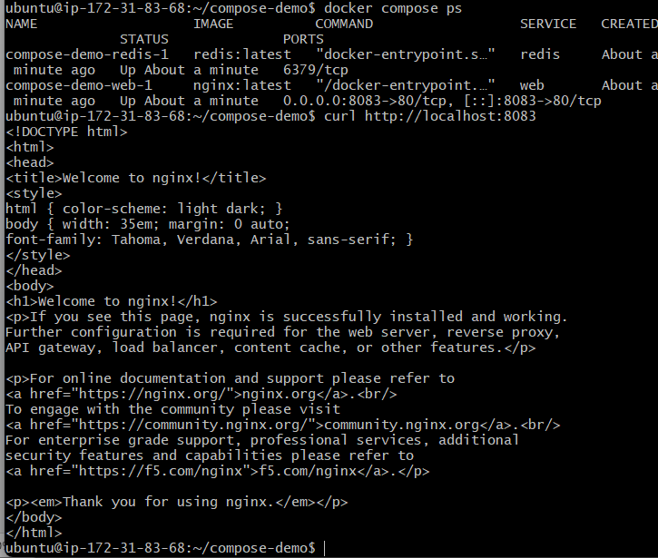

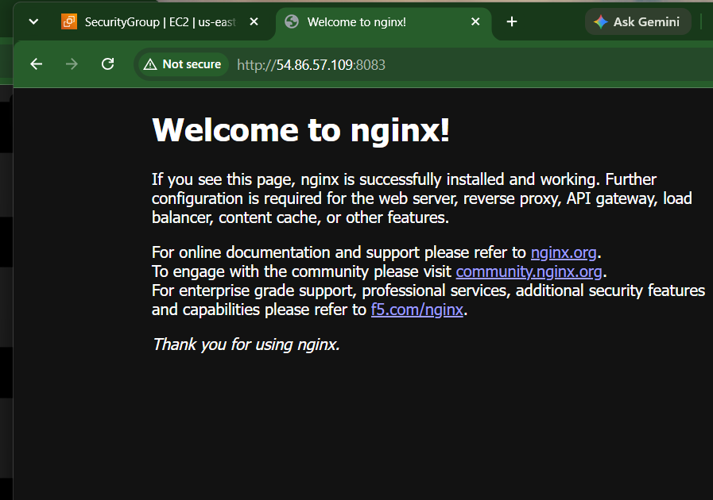
View logs:
docker compose logs
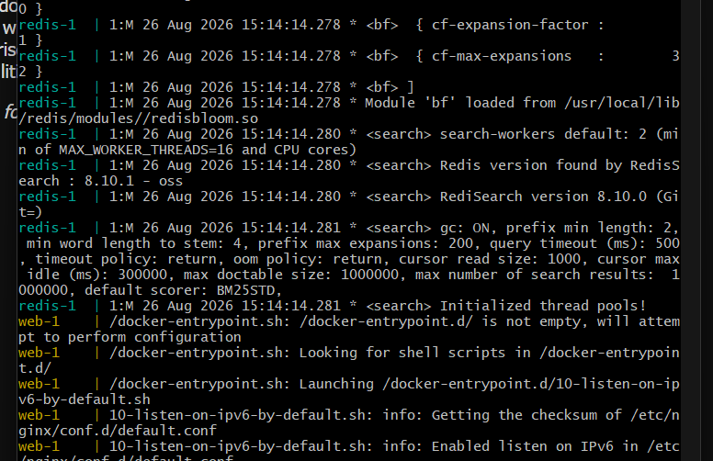
Stop:
docker compose down
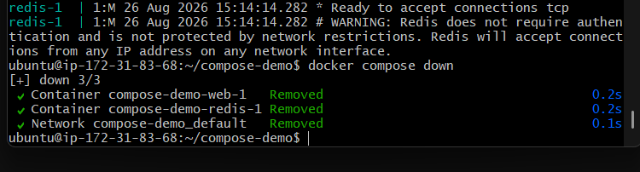

Useful Commands
docker compose up -d
Starts the application in detached mode.
docker compose ps
Displays the containers created by Compose.
docker compose logs
Displays application logs.
docker compose down
Stops and removes the Compose application's containers and network.

6. Scan Images When Pushed to Docker Registry

Objective
Implement image vulnerability scanning so that a Docker image is checked for security vulnerabilities when it is pushed to a container registry.

Outcome
You will establish a security gate in the container image lifecycle:
Developer
↓
Docker Build
↓
Security Scan
↓
Docker Registry
↓
Deployment
There are multiple ways to implement this.
A practical lab solution is Trivy + Docker Hub.

Step 1: Implementation
Install Trivy on the system where the image is built.
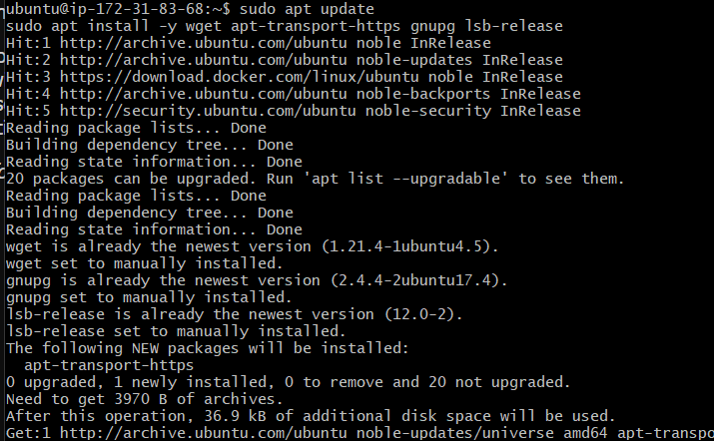
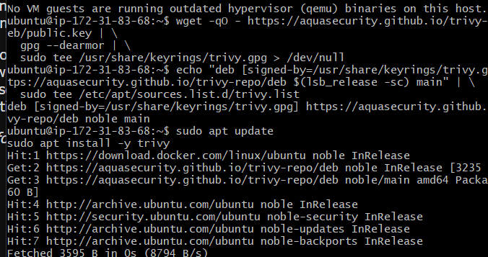
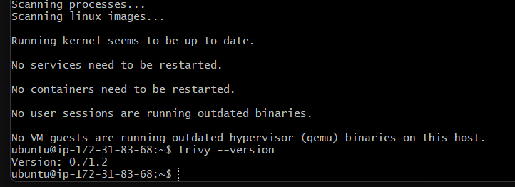

Step 2 — Create a Test Docker Image
Create a directory:
mkdir ~/trivy-demo
cd ~/trivy-demo
Create a Dockerfile:
vi Dockerfile
Put:
FROM nginx:latest

COPY index.html /usr/share/nginx/html/index.html
Create the HTML file:
vi index.html
Put:
<html>
<head>
<title>Trivy Demo</title>
</head>
<body>
<h1>Docker Registry Security Scan</h1>
</body>
</html>

Step 3 — Build the Image
docker build -t trivy-demo:v1 .
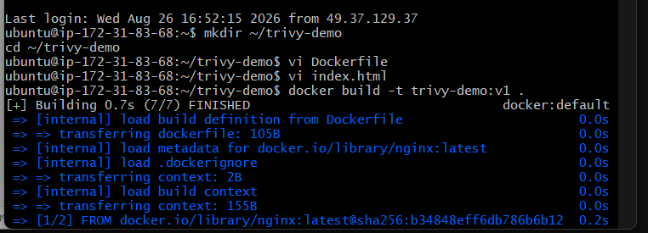
Check:
docker images
You should see:
trivy-demo v1
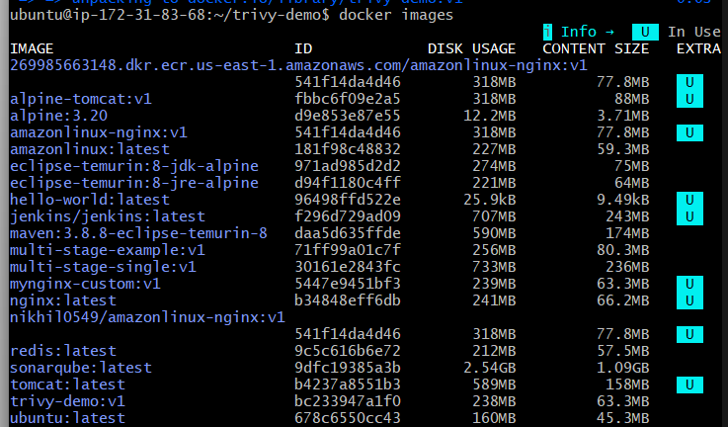

Step 4 — Scan the Image
Run:
trivy image trivy-demo:v1
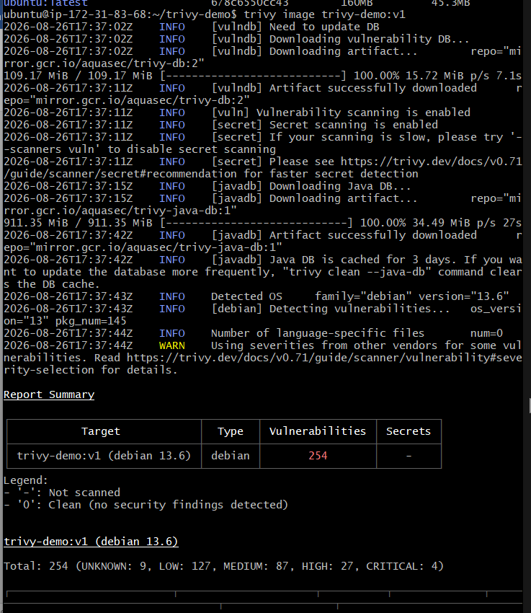
Trivy will inspect the image for known vulnerabilities.
You can specifically scan HIGH and CRITICAL vulnerabilities:
trivy image --severity HIGH,CRITICAL trivy-demo:v1
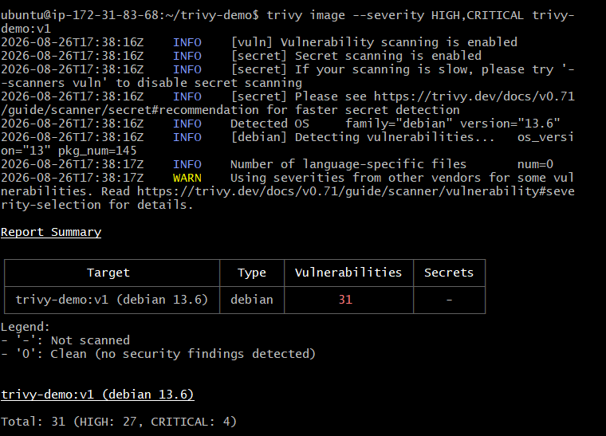

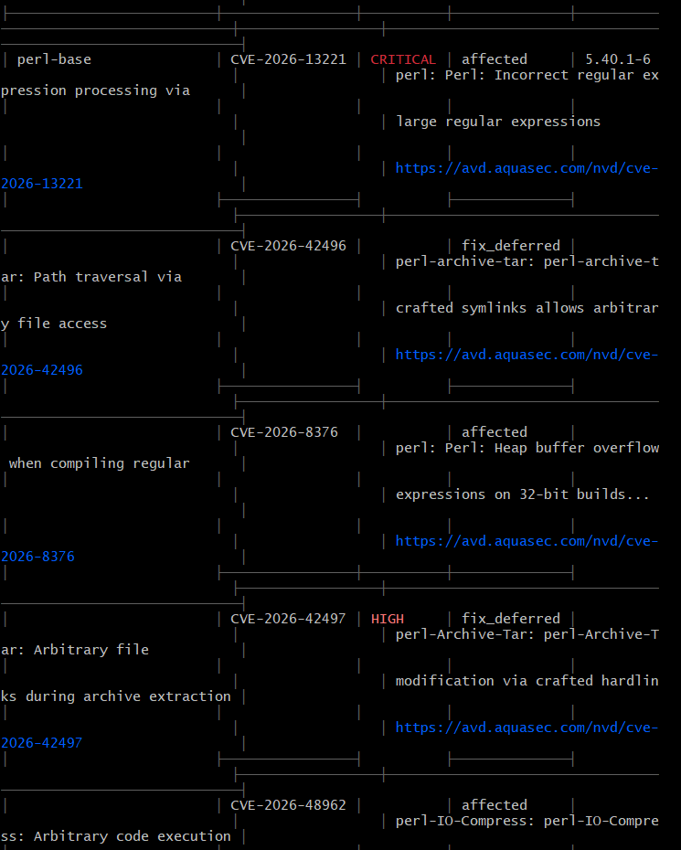

Step 5 — Make the Scan a Security Gate
This is the important part for the task.
Run:
trivy image \
--severity HIGH,CRITICAL \
--exit-code 1 \
trivy-demo:v1

What does --exit-code 1 do?
Normally Trivy can report vulnerabilities and still exit successfully.
With:
--exit-code 1
Trivy returns exit code 1 when vulnerabilities matching your severity selection are found.
So your pipeline can do:
Trivy scan
↓
Exit code 0 → Continue
Exit code 1 → Stop

Step 6 — Login to Docker Hub
If you already have a Docker Hub account:
docker login
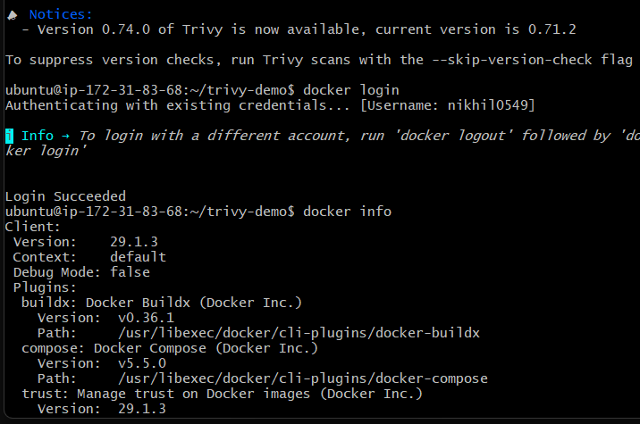
Enter your Docker Hub username and preferably a Docker Hub access token as the password.
Verify:
docker info
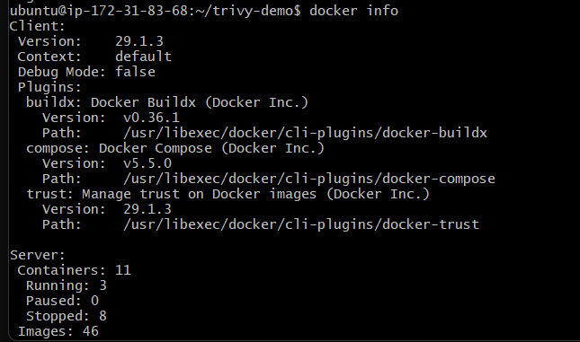

Step 7 — Tag the Image
Replace <DOCKERHUB_USERNAME> with your Docker Hub username:
docker tag trivy-demo:v1 <DOCKERHUB_USERNAME>/trivy-demo:v1
Check:
docker images
You should have:
trivy-demo
<DOCKERHUB_USERNAME>/trivy-demo
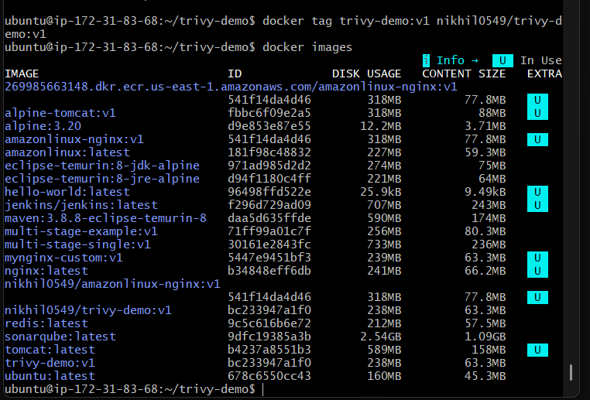

Step 8 — Implement the Actual Push Gate
Instead of running the scan and then manually pushing regardless of the result, combine the commands:
trivy image \
--severity HIGH,CRITICAL \
--exit-code 1 \
<DOCKERHUB_USERNAME>/trivy-demo:v1 && \
docker push <DOCKERHUB_USERNAME>/trivy-demo:v1
The && means:
Trivy succeeds
↓
docker push runs

Trivy fails
↓
docker push does NOT run
This is the core implementation for Task 6.
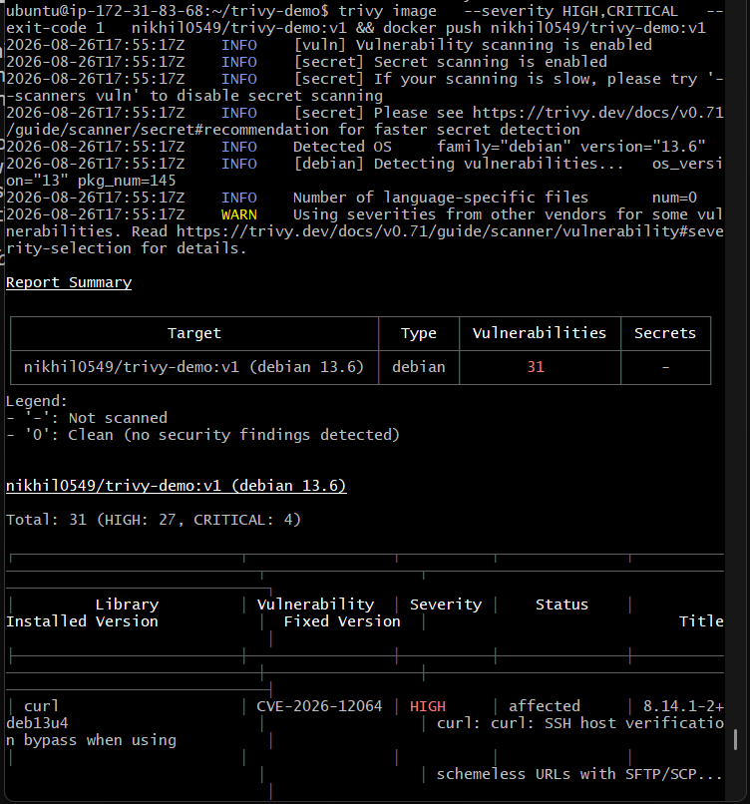

Step 9 — Test the Complete Flow
First build:
docker build -t trivy-demo:v1 .
Tag:
docker tag trivy-demo:v1 <DOCKERHUB_USERNAME>/trivy-demo:v1
Scan:
trivy image \
--severity HIGH,CRITICAL \
--exit-code 1 \
<DOCKERHUB_USERNAME>/trivy-demo:v1
If the scan passes:
docker push <DOCKERHUB_USERNAME>/trivy-demo:v1
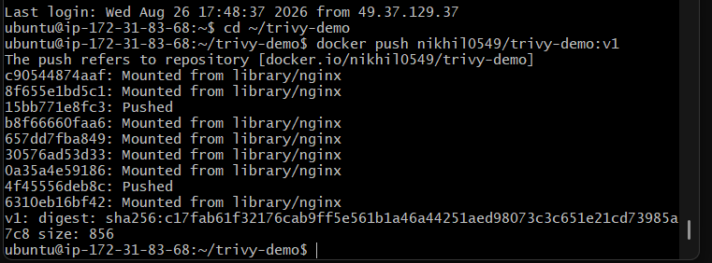
If the scan fails, the image should not be pushed.

Step 10 — Verify in Docker Hub
After a successful push, open your Docker Hub repository and verify that:
trivy-demo
└── v1
exists.
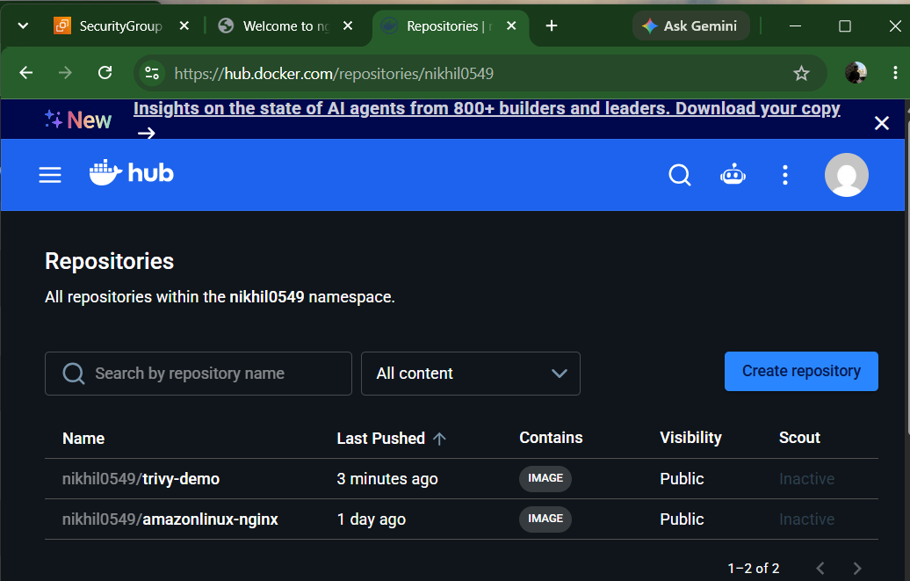
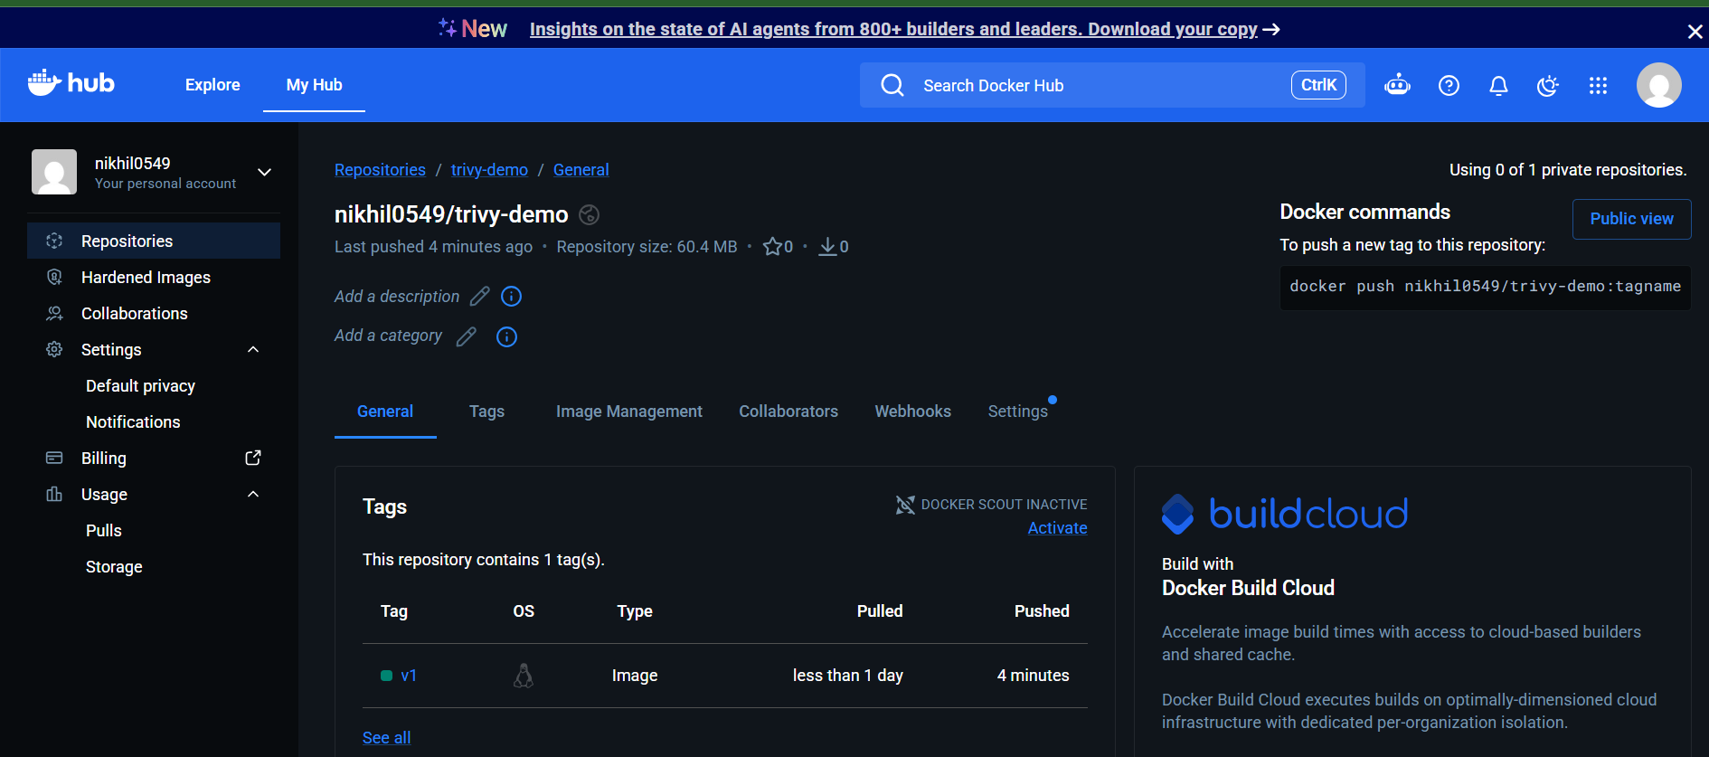

7. Scan Images When Pushed to AWS ECR

Objective
Configure AWS ECR so that whenever a Docker image is pushed to an ECR repository, AWS automatically scans the image for vulnerabilities.

Outcome
You will have:
Docker Image
↓
docker push
↓
AWS ECR
↓
Automatic Scan on Push
↓
Vulnerability Findings

Step 1 — Check AWS CLI
On your Ubuntu EC2 server:
aws --version
Then check your AWS identity:
aws sts get-caller-identity
You should get your AWS account and IAM identity.

Step 2 — Choose your AWS Region
You've been using us-east-1, so we'll use that.
aws configure get region
If it doesn't return us-east-1, you can specify the region explicitly in the commands below.
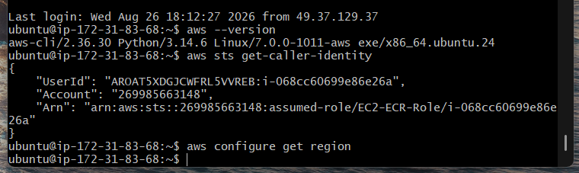

Step 3 — Create an ECR Repository
Run:
aws ecr create-repository \
--repository-name task7-ecr-scan \
--region us-east-1
You should receive repository information.
Verify:
aws ecr describe-repositories \
--repository-names task7-ecr-scan \
--region us-east-1

Step 4 — Configure ECR Scan on Push
Amazon ECR Basic scanning is enabled by default for private registries, but repositories can be configured with scan-on-push filters.
The easiest way for your lab is through the AWS Console.
Go to:
AWS Console → ECR → Private registry → Scanning
Select:
Scan type: Basic scanning
Then configure Scan on push for your repository, such as:
task7-ecr-scan
Save the configuration.
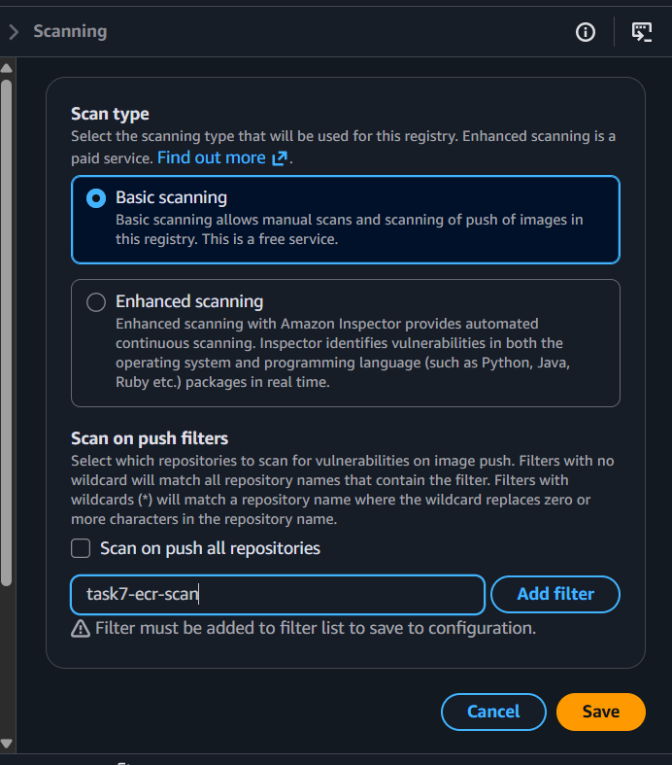
AWS documents that repositories matching a Basic-scanning scan-on-push filter are scanned automatically when a new image is pushed.

Step 5 — Authenticate Docker to ECR
First get your AWS account ID:
aws sts get-caller-identity \
--query Account \
--output text
Suppose it returns:
123456789012
Log in to ECR:
aws ecr get-login-password --region us-east-1 | \
docker login \
--username AWS \
--password-stdin 123456789012.dkr.ecr.us-east-1.amazonaws.com
You should get:
Login Succeeded
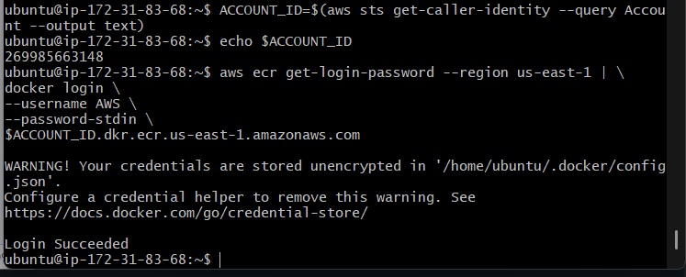

Step 6 — Build a Test Image
Create a simple image.
mkdir -p ~/task7-ecr
cd ~/task7-ecr
Create the Dockerfile:
vi Dockerfile
Put:
FROM nginx:latest

RUN echo "AWS ECR Image Scan Demo" > /usr/share/nginx/html/index.html
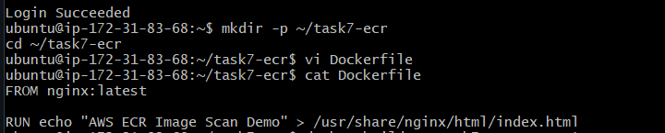
Build:
docker build -t task7-ecr-scan:v1 .
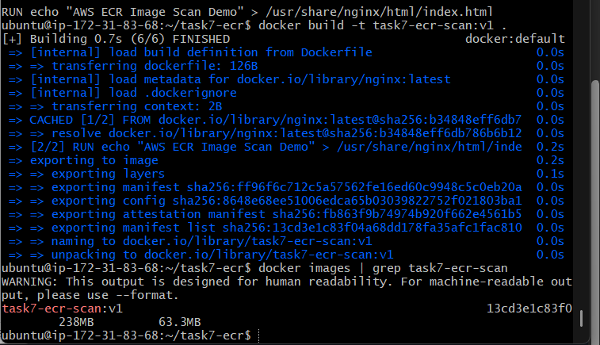
Check:
docker images

Step 7 — Tag the Image for ECR
Set your account ID:
ACCOUNT_ID=$(aws sts get-caller-identity --query Account --output text)
Check:
echo $ACCOUNT_ID
Tag:
docker tag task7-ecr-scan:v1 \
$ACCOUNT_ID.dkr.ecr.us-east-1.amazonaws.com/task7-ecr-scan:v1
Verify:
docker images
You should have something like:
task7-ecr-scan:v1

123456789012.dkr.ecr.us-east-1.amazonaws.com/task7-ecr-scan:v1
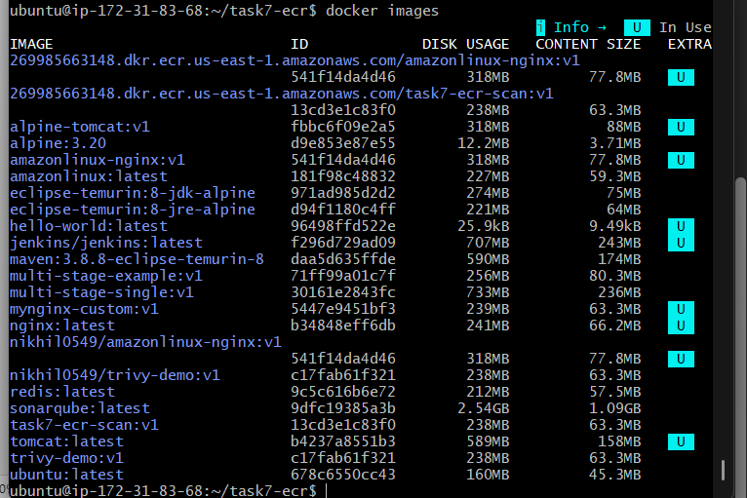

Step 8 — Push the Image
Now push it:
docker push \
$ACCOUNT_ID.dkr.ecr.us-east-1.amazonaws.com/task7-ecr-scan:v1
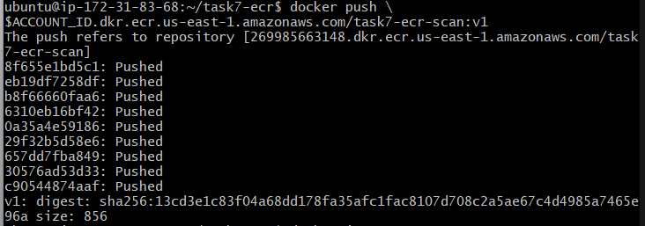
The image is now stored in ECR.
Because scan on push is configured, ECR automatically starts the vulnerability scan.

Step 9 — Check the Scan Findings
Use:
aws ecr describe-image-scan-findings \
--repository-name task7-ecr-scan \
--image-id imageTag=v1 \
--region us-east-1
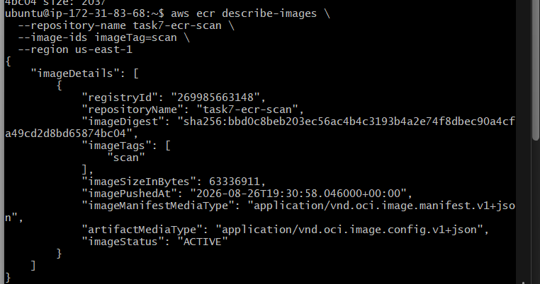
This returns the vulnerability findings for the image.
The current ECR documentation specifically recommends DescribeImageScanFindings for retrieving Basic scanning findings.
You can make the output easier to read:
aws ecr describe-image-scan-findings \
--repository-name task7-ecr-scan \
--image-id imageTag=v1 \
--region us-east-1 \
--query 'imageScanFindings.findings[*].[severity,name,uri]' \
--output table
You may see severities such as:
CRITICAL
HIGH
MEDIUM
LOW

Step 10 — Check from AWS Console
Go to:
AWS Console → ECR → Repositories → task7-ecr-scan
Click:
v1
Then look for the image's scan findings / vulnerabilities.
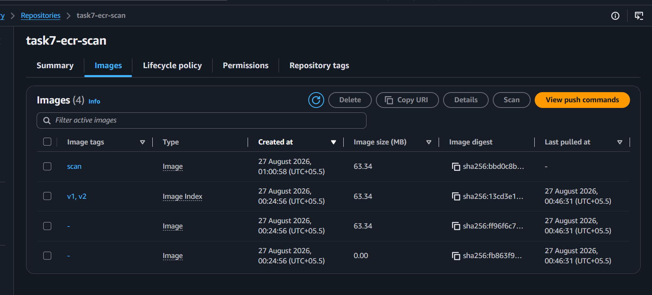
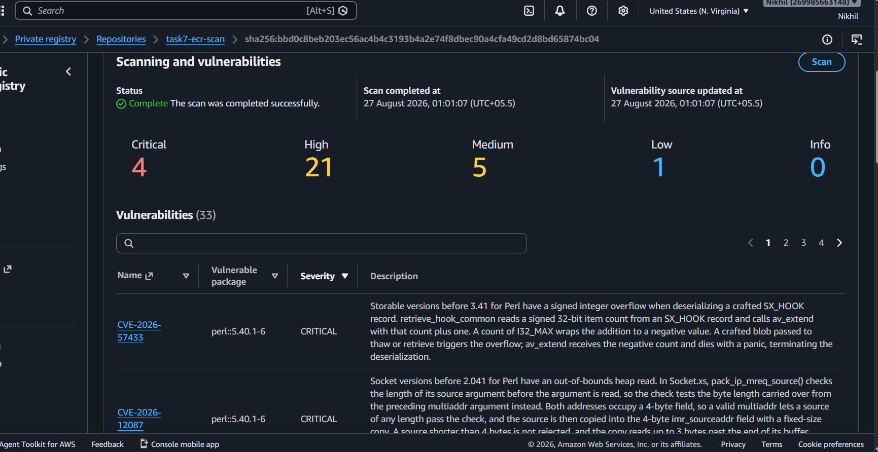
This is useful as evidence for your task because you can show:
Repository
↓
Image: v1
↓
Scan completed
↓
Vulnerability findings

8. Jenkins Pipeline — Build Docker Image and Push to Docker Hub

Objective
Create a Jenkins CI/CD pipeline that automatically builds a Docker image and pushes it to Docker Hub.

Outcome
You will implement a complete container image CI pipeline:
Developer Push
↓
Jenkins
↓
Git Checkout
↓
Docker Build
↓
Docker Login
↓
Docker Push
↓
Docker Hub

Prerequisites
Jenkins should have:
- Docker installed
- Git installed
- Docker daemon access
- Docker Hub account
- Docker Hub credentials stored in Jenkins

Jenkins Credentials
In Jenkins:
Manage Jenkins
↓
Credentials
↓
Global credentials
↓
Add Credentials
Use:
Kind: Username with password
For example:
Username: your Docker Hub username
Password: Docker Hub access token
ID: dockerhub-creds
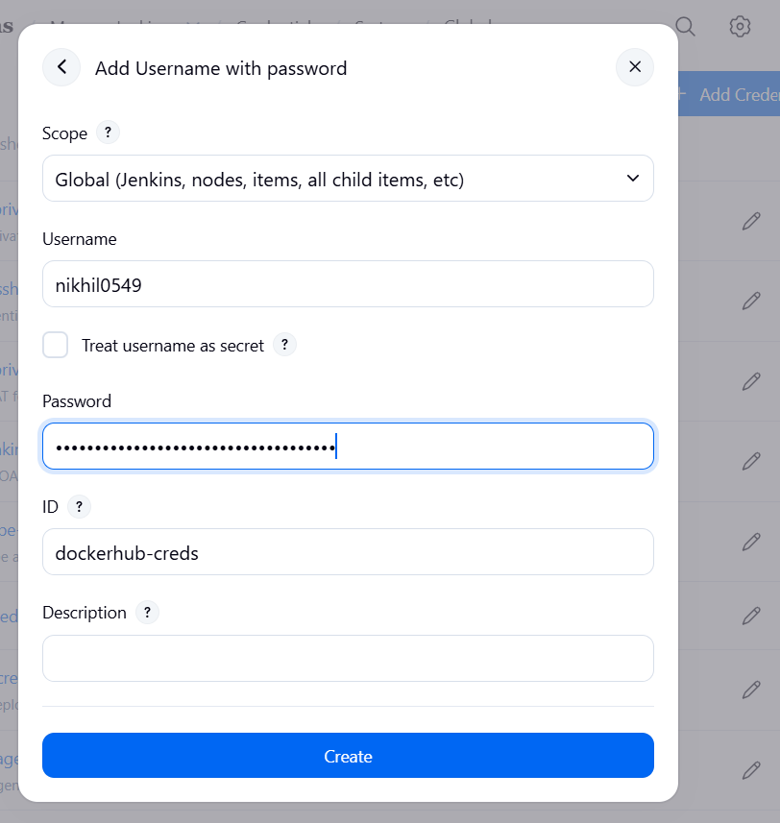
Using a Docker Hub access token is preferable to storing the Docker Hub account password.

Jenkinsfile

Create/open your Jenkins Pipeline job
In Jenkins:
Dashboard → New Item
Choose:
Pipeline
Give it a name, for example:
dockerhub-push
Click OK.
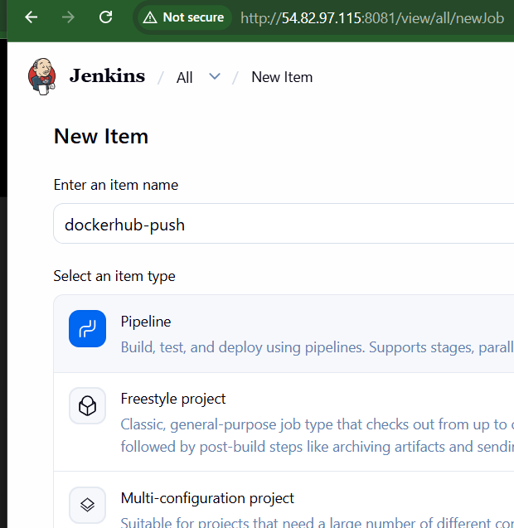

3. Enter your pipeline
Go to:
Pipeline → Definition → Pipeline script
For your repository, you can use this basic declarative pipeline:
pipeline {

agent any

environment {
IMAGE_NAME = 'your-dockerhub-username/myapp'
IMAGE_TAG = "${BUILD_NUMBER}"
}

stages {

stage('Checkout') {
steps {
git branch: 'main',
url: 'https://github.com/your-username/your-repository.git'
}
}

stage('Build Docker Image') {
steps {
sh '''
docker build \
-t ${IMAGE_NAME}:${IMAGE_TAG} \
.
'''
}
}

stage('Docker Login') {
steps {
withCredentials([
usernamePassword(
credentialsId: 'dockerhub-creds',
usernameVariable: 'DOCKER_USERNAME',
passwordVariable: 'DOCKER_PASSWORD'
)
]) {
sh '''
echo "$DOCKER_PASSWORD" | \
docker login \
-u "$DOCKER_USERNAME" \
--password-stdin
'''
}
}
}

stage('Push Docker Image') {
steps {
sh '''
docker push ${IMAGE_NAME}:${IMAGE_TAG}
'''
}
}
}

post {
success {
echo "Docker image pushed successfully: ${IMAGE_NAME}:${IMAGE_TAG}"
}

failure {
echo "Docker image build or push failed."
}

always {
sh 'docker logout || true'
}
}
}
Replace:
your-dockerhub-username
and:
your-repository
with your actual values.
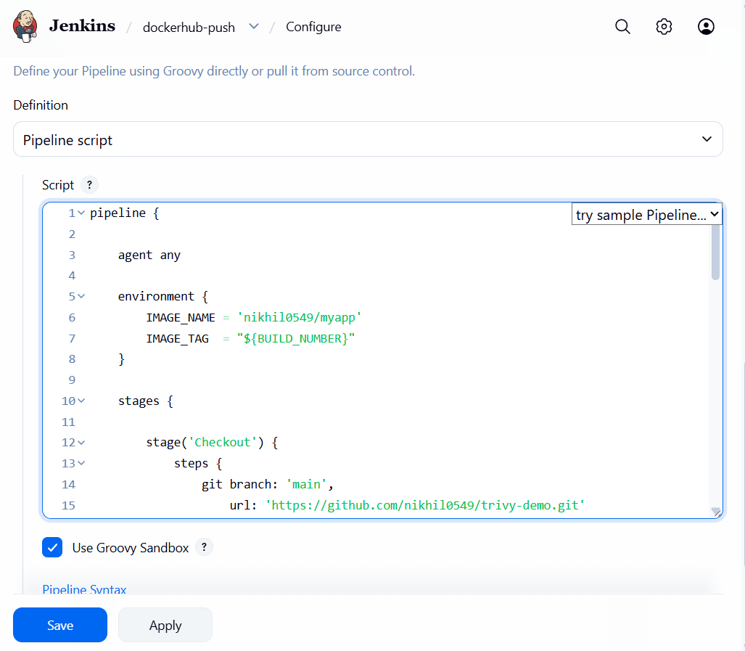

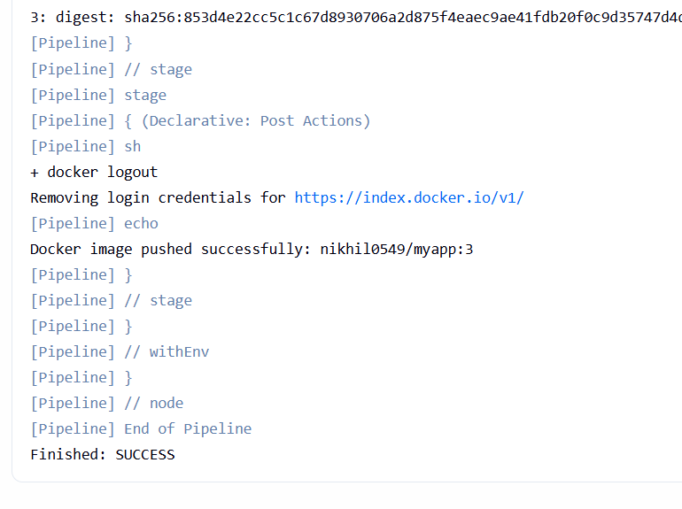

Verify the image in Docker Hub
Go to your Docker Hub repository:
nikhil0549/myapp
You should see a tag corresponding to your Jenkins build number.
For example, if this was Build #1:
nikhil0549/myapp:1
If you run it again as Build #2:
nikhil0549/myapp:2
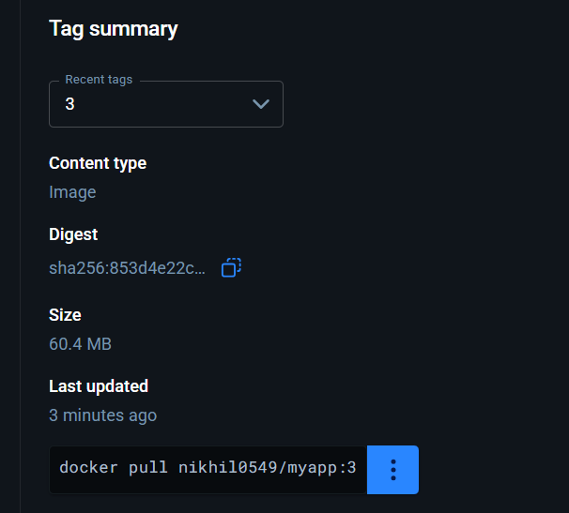
You can do one final verification from your EC2:
docker pull nikhil0549/myapp:3
If you see something like:
Status: Downloaded newer image for nikhil0549/myapp:3
then the complete GitHub → Jenkins → Docker Hub workflow is verified. ✅
